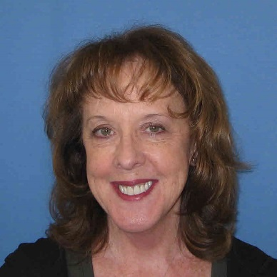
Christie Carlsen At-Large Nominee

Christie Carlsen has been working for DOC for fourteen years. She is currently a correctional counselor at North Central Correctional Facility. She brings to the ICA committee many talents including: dedication, confidence, self-driven commitments, and a love for challenges!
Currently: She is in her research phase of working on her PhD in Advance Studies in Human Behavior. Before coming to Corrections; she was a college instructor. When she made the career move from college professor to the Iowa Department of Corrections in 2003; she came into corrections with a MA in Education from UNI. She is one who started from entry level to current position of treatment/caseload counselor to earn a wealth of well-rounded knowledge and skills; to perform duties most effectively. This has given her a better perspective on security and treatment goals of corrections.
She is one who is self-directing, confident, and communicates well her perspective direction of goals and objections in completing tasks! Challenges are her driving force to successes and will not dodge an opportunity to show her talents!

